NAME: KARTHIGA G SLOT: A
REG NO:192421383 SUB: CLOUD COMPUTING

6. HOSPITAL MANAGEMENT SYSTEM (SaaS)
AIM
To develop a Hospital Management System and deploy it as SaaS using Zoho Creator.
ALGORITHM
- Start
- Login to Zoho Creator
- Create application
- Create patient form
- Add patient and doctor details
- Create report
- Run application
- Enter patient data
- Display patient details
- Share application link
- Stop
PROCEDURE
- Create application (HospitalManagementApp)
- Create form (PatientForm)
- Add fields: Name, Age, Gender, Doctor, Department, Date, Phone, Email
- Create report (PatientReport)
- Run application and enter data
- View patient details in report
- Share application link

OUTPUT SCREENSHOT
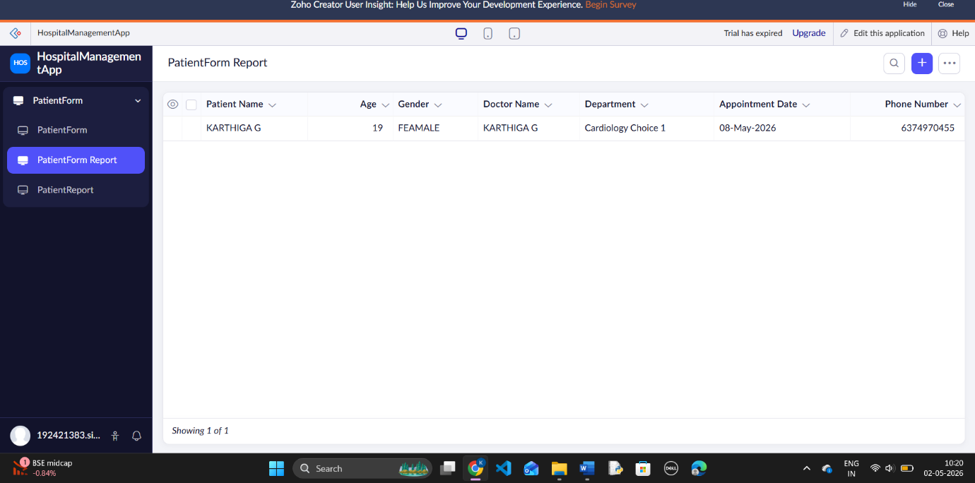

RESULT
A Hospital Management System was successfully developed and deployed as SaaS using Zoho Creator.

